Association

📌 Definition:
# Source: AI Source: Provided by: [Data Path: Persons Table -> ID Column: 1, Name_En Column: Motasem Essam] -> From: [Chatgpt (GPT‑5 Mini)] on [12/9/2025]
Association is a relationship between two or more objects where they are connected or interact with each other, but each object can exist independently.

🧠 Simple idea:
# Source: AI Source: Provided by: [Data Path: Persons Table -> ID Column: 1, Name_En Column: Motasem Essam] -> From: [Chatgpt (GPT‑5 Mini)] on [12/9/2025]
Association = “uses-a” relationship 🤝

🔍 Key characteristics:
# Source: AI Source: Provided by: [Data Path: Persons Table -> ID Column: 1, Name_En Column: Motasem Essam] -> From: [Chatgpt (GPT‑5 Mini)] on [12/9/2025]
- 🔗 Objects are linked but independent
- 🧩 No ownership between objects
- 🔄 Represents real-world relationships
- ⚙️ Can be one-to-one, one-to-many, many-to-many

📌 Example (Java-style):
# Source: AI Source: Provided by: [Data Path: Persons Table -> ID Column: 1, Name_En Column: Motasem Essam] -> From: [Chatgpt (GPT‑5 Mini)] on [12/9/2025]
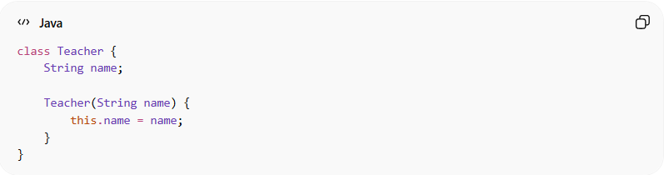
class Teacher {
String name;

Teacher(String name) {
this.name = name;
}
}
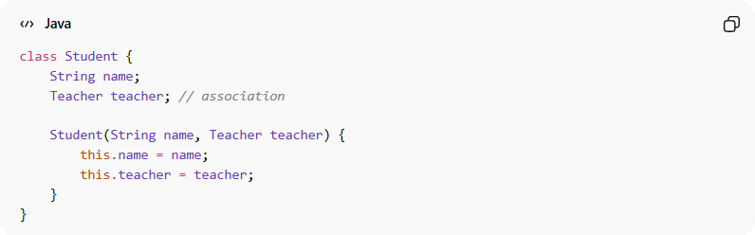
class Student {
String name;
Teacher teacher; // association

Student(String name, Teacher teacher) {
this.name = name;
this.teacher = teacher;
}
}

Usage:
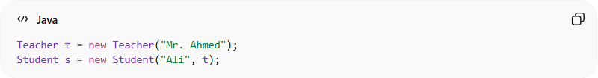
Teacher t = new Teacher("Mr. Ahmed");
Student s = new Student("Ali", t);
👉 The Student uses the Teacher, but both can exist separately.

🔄 Types of Association:

1️⃣ One-to-One
# Source: AI Source: Provided by: [Data Path: Persons Table -> ID Column: 1, Name_En Column: Motasem Essam] -> From: [Chatgpt (GPT‑5 Mini)] on [12/9/2025]
- One object ↔ One object
- Example: Person ↔ Passport

2️⃣ One-to-Many
# Source: AI Source: Provided by: [Data Path: Persons Table -> ID Column: 1, Name_En Column: Motasem Essam] -> From: [Chatgpt (GPT‑5 Mini)] on [12/9/2025]
- One object → Many objects
- Example: Teacher → Students

3️⃣ Many-to-Many
# Source: AI Source: Provided by: [Data Path: Persons Table -> ID Column: 1, Name_En Column: Motasem Essam] -> From: [Chatgpt (GPT‑5 Mini)] on [12/9/2025]
- Many objects ↔ Many objects
- Example: Students ↔ Courses

🆚 Real-world example:
# Source: AI Source: Provided by: [Data Path: Persons Table -> ID Column: 1, Name_En Column: Motasem Essam] -> From: [Chatgpt (GPT‑5 Mini)] on [12/9/2025]
- 🎓 Teacher teaches Students
- 🧑‍💼 Employee works in Company
- 🚗 Driver drives Car
👉 These are associations, not ownerships.

🎯 Why Association is important:
# Source: AI Source: Provided by: [Data Path: Persons Table -> ID Column: 1, Name_En Column: Motasem Essam] -> From: [Chatgpt (GPT‑5 Mini)] on [12/9/2025]
- 🧩 Models real-world relationships
- 🔄 Improves system design
- ⚙️ Keeps objects loosely coupled
- 🧠 Makes systems flexible

🎯 Summary:
# Source: AI Source: Provided by: [Data Path: Persons Table -> ID Column: 1, Name_En Column: Motasem Essam] -> From: [Chatgpt (GPT‑5 Mini)] on [12/9/2025]
Association represents a relationship where objects are connected and interact, but they remain independent of each other.

